Steps in Setting Up a Project
Content
Discussion
Setting up a web project involves several steps, from defining project requirements to configuring development environments and deploying the project to a production server.

Step 1: Define Project Requirements
1. Define Project Goals: Clearly outline the purpose and objectives of the web project.
2. Identify Target Audience: Determine the intended users and their needs.
3. Gather Functional Requirements: List the features and functionalities required for the project.
4. Document Technical Specifications: Specify the technologies, platforms, and frameworks to be used.

Step 2: Choose Development Tools and Technologies
1. Select Programming Languages: Choose the appropriate programming languages based on project requirements (e.g., HTML, CSS, JavaScript, PHP, Python).
2. Choose Development Frameworks: Select frameworks and libraries (e.g., React, Angular, Vue.js) to streamline development.
3. Pick a Version Control System: Decide on a version control system (e.g., Git) for managing project code.
4. Select Development Environment: Choose an Integrated Development Environment (IDE) or code editor (e.g., Visual Studio Code, Sublime Text) for writing and editing code.

Step 3: Setup Local Development Environment
1. Install Required Software:
- Install necessary software such as Node.js, npm (Node Package Manager), Git, and a web server (e.g., Apache, Nginx).
2. Initialize Version Control:
- Initialize a Git repository in the project directory using the command `git init`.
3. Create Project Structure:
- Create directories for different project components (e.g., `src` for source code, `public` for static assets).
4. Install Dependencies:
- Use npm or yarn to install project dependencies defined in the `package.json` file (e.g., `npm install` or `yarn install`).

Step 4: Develop Project Components
1. Design User Interface (UI):
- Create wireframes and mockups to visualize the layout and design of the web application.
- Use HTML, CSS, and JavaScript to develop the user interface based on the design specifications.
2. Implement Functionality:
- Write backend code (e.g., server-side scripts, APIs) using the selected programming language and framework.
- Implement frontend functionality using JavaScript frameworks and libraries (e.g., React, Angular).
3. Test Components:
- Write unit tests and integration tests to ensure the reliability and functionality of project components.
- Use testing frameworks (e.g., Jest, Mocha) for automated testing.

Step 5: Configure Build and Deployment Processes
1. Setup Build Tools:
- Configure build tools (e.g., Webpack, Gulp) to bundle and optimize project assets for production.
2. Configure Continuous Integration (CI):
- Setup CI/CD pipelines using services like GitHub Actions, Travis CI, or Jenkins for automated testing and deployment.
3. Optimize Performance:
- Optimize assets (e.g., minify CSS and JavaScript, optimize images) to improve page load times and overall performance.
4. Setup Deployment Environments:
- Configure staging and production environments for deploying the web project.
5. Deploy Project:
- Deploy the project to the production server using deployment scripts or tools (e.g., FTP, SSH, deployment services like Netlify or Vercel).

Step 6: Monitor and Maintain Project
1. Monitor Performance:
- Monitor website performance, uptime, and user interactions using analytics tools (e.g., Google Analytics, New Relic).
2. Collect User Feedback:
- Gather user feedback through surveys, user testing, and analytics to identify areas for improvement.
3. Perform Regular Updates:
- Regularly update project dependencies, frameworks, and libraries to ensure security and compatibility.
4. Handle Bug Fixes and Issues:
- Address bugs, errors, and user-reported issues promptly to maintain the stability and usability of the web project.
5. Backup Data:
- Implement regular backups of project data and files to prevent data loss in case of system failures or security breaches.

Step 7: Document Project Setup and Usage
1. Create Documentation:
- Document the project setup process, including installation instructions, configuration steps, and usage guidelines.
2. Write Code Documentation:
- Generate code documentation using tools like JSDoc or Doxygen to provide detailed documentation of project code.
3. Maintain README File:
- Update the README file with project information, setup instructions, and any other relevant details for developers and contributors.

By following these steps, you can effectively set up and manage a web project from start to finish, ensuring that it meets the requirements and goals set forth at the beginning of the project lifecycle.

Simple Learning Management System -
Content
Discussion

Introduction:
The Learning Management System (LMS) is a web-based application designed to facilitate the administration, delivery, and tracking of educational courses or training programs. The LMS provides features such as user registration, authentication, course selection, and leaderboards to enhance the learning experience.

Key Features:
User Registration:
- Allows new users to create an account by providing basic information such as username, email, and password.
- Validates user input to ensure data integrity and security.
- Stores user information securely in the database.
User Authentication:
- Authenticates registered users to access the LMS features.
- Implements secure authentication mechanisms such as password hashing and session management.
- Restricts access to certain functionalities based on user roles (e.g., student, instructor, admin).
Course Management:
- Provides a user-friendly interface for students to browse and enroll in available courses.
Course Enrollment:
- Allows students to search for courses.
- Enables students to enroll in courses of interest with a single click.
- Automatically updates enrolled students' course lists.
Leaderboard:
- Displays a leaderboard ranking students based on scores.

Technical Implementation:
Frontend Development:
- Utilizes HTML, CSS, and JavaScript to create an interactive and responsive user interface with menus, course cards, forms, and dashboards for seamless user experience.
Backend Development:
- Utilizes Node.js as the server-side runtime environment.
- Implements Express.js as the web application framework for routing and middleware functionalities.
- Integrates MySQL as the database management system to store user data, course information, and leaderboard scores.
Authentication and Authorization:
- Implements user authentication using techniques such as username/password authentication
- Stores and manages user sessions to ensure data privacy and security.
- Course Management and Enrollment:
- Provides a user-friendly interface for learners to browse and enroll in courses.
- Manages course enrollment status and updates student course lists dynamically.
Leaderboard Implementation:
- display leaderboard rankings dynamically.
LMS Project Setup
Content
Discussion

Step 1: Project Setup

Create a new directory for your project and navigate into it.

mkdir learning-management-app
cd learning-management-app

Initialize a new Node.js project.

npm init -y

Install necessary dependencies.

npm install express mysql ejs bcryptjs express-session express-validator

Step 2: Set up the Backend

Create a server.js file in your project directory.

Create a MySQL database named learning_management

Create users table

-- Create users table
CREATE TABLE users (
id INT AUTO_INCREMENT PRIMARY KEY,
username VARCHAR(255) UNIQUE,
password VARCHAR(255),
email VARCHAR(255) UNIQUE,
full_name VARCHAR(255)
);

Create courses table

-- Create courses table
CREATE TABLE courses (
id INT AUTO_INCREMENT PRIMARY KEY,
name VARCHAR(255)
);

-- Insert sample data into courses table
INSERT INTO courses (name) VALUES
('Introduction to HTML'),
('CSS Fundamentals'),
('JavaScript Basics');

Create leaderboard table

-- Create leaderboard table
CREATE TABLE leaderboard (
id INT AUTO_INCREMENT PRIMARY KEY,
name VARCHAR(255),
score INT
);

-- Insert sample data into leaderboard table
INSERT INTO leaderboard (name, score) VALUES
('John Doe', 100),
('Jane Smith', 90),
('Michael Brown', 85),
('Emily Jones', 80);

Run the server.

node server.js

Step 3: Frontend Setup

Create an index.html file for the frontend.

Create a course-content.html file for the course content.

Create a leader-board.html file for the leader board.

Create a style.css file to style your HTML.

Create a script.js file to handle frontend interactions.

Index.html

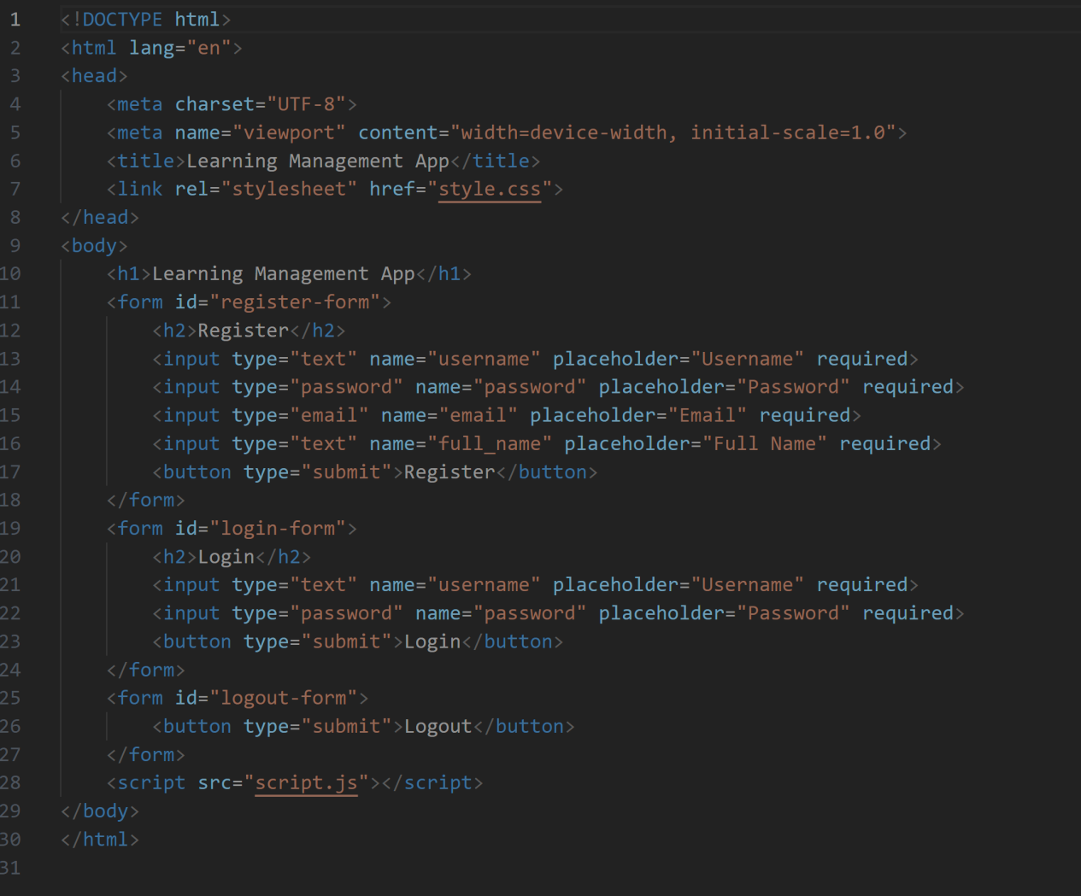

dashboard.html

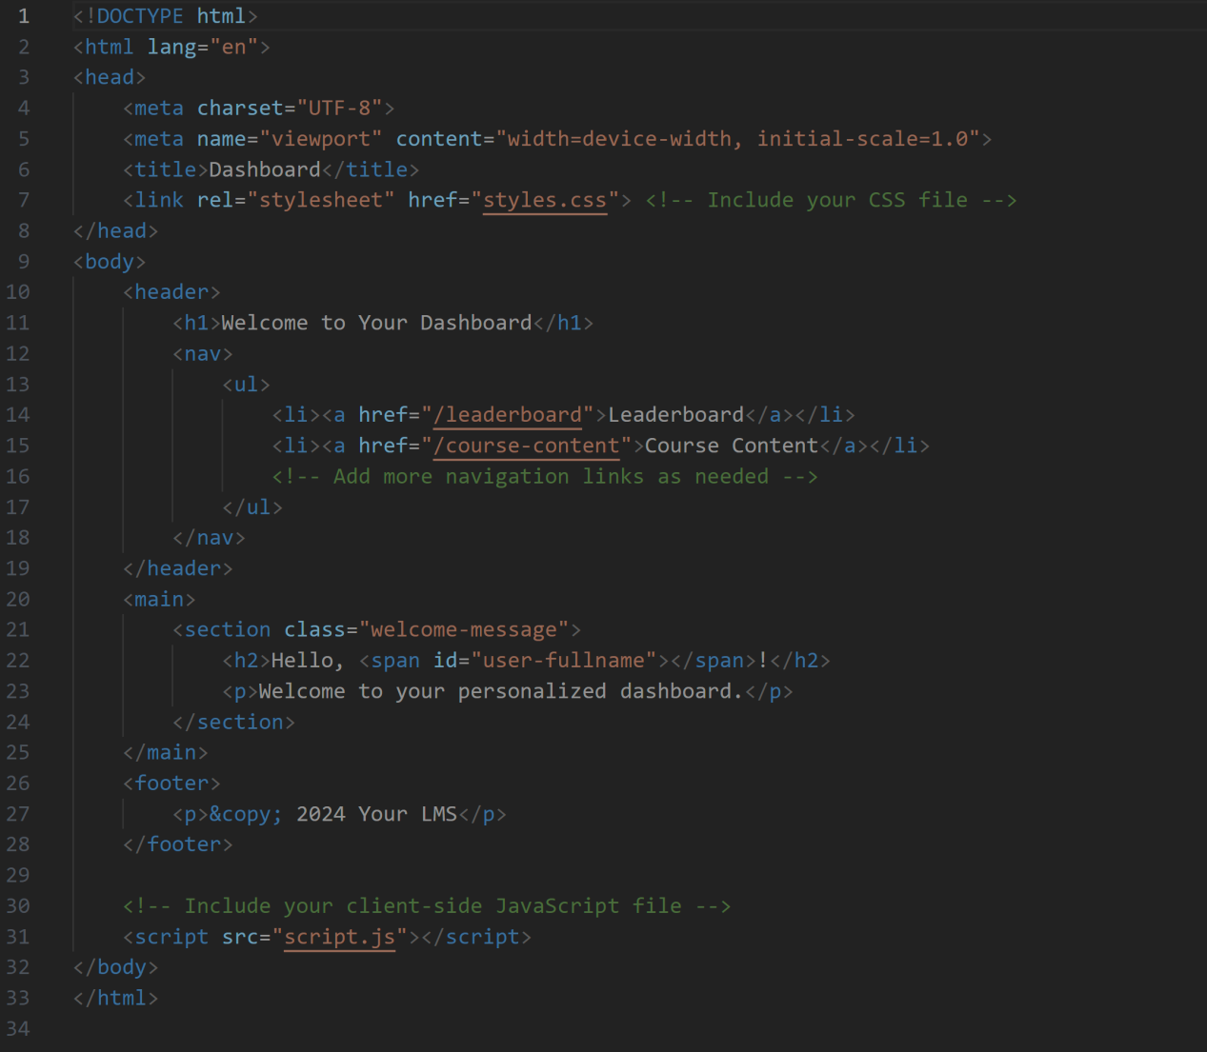

course-content.html
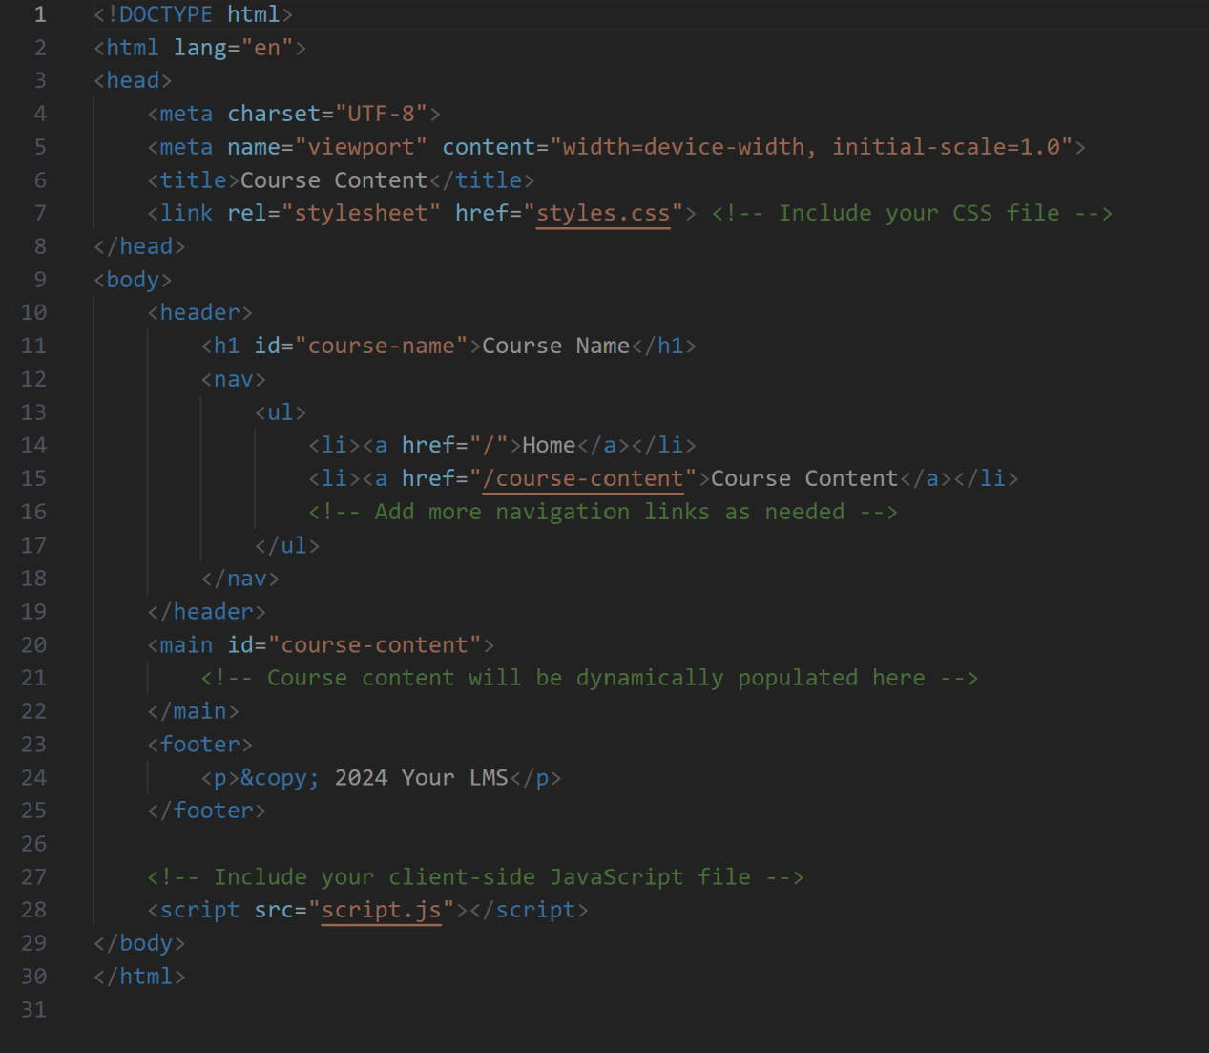

leaderboard.html

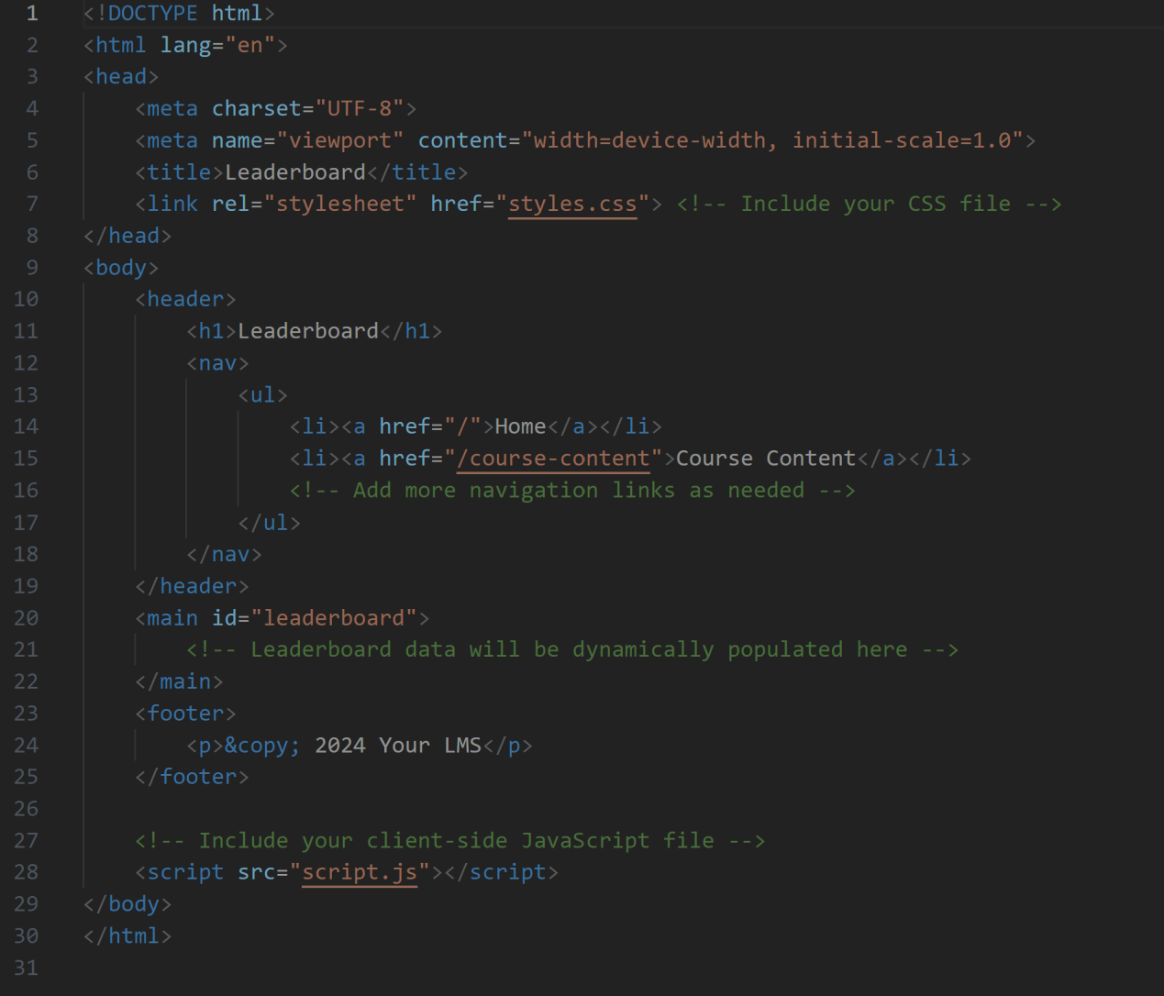

style.css

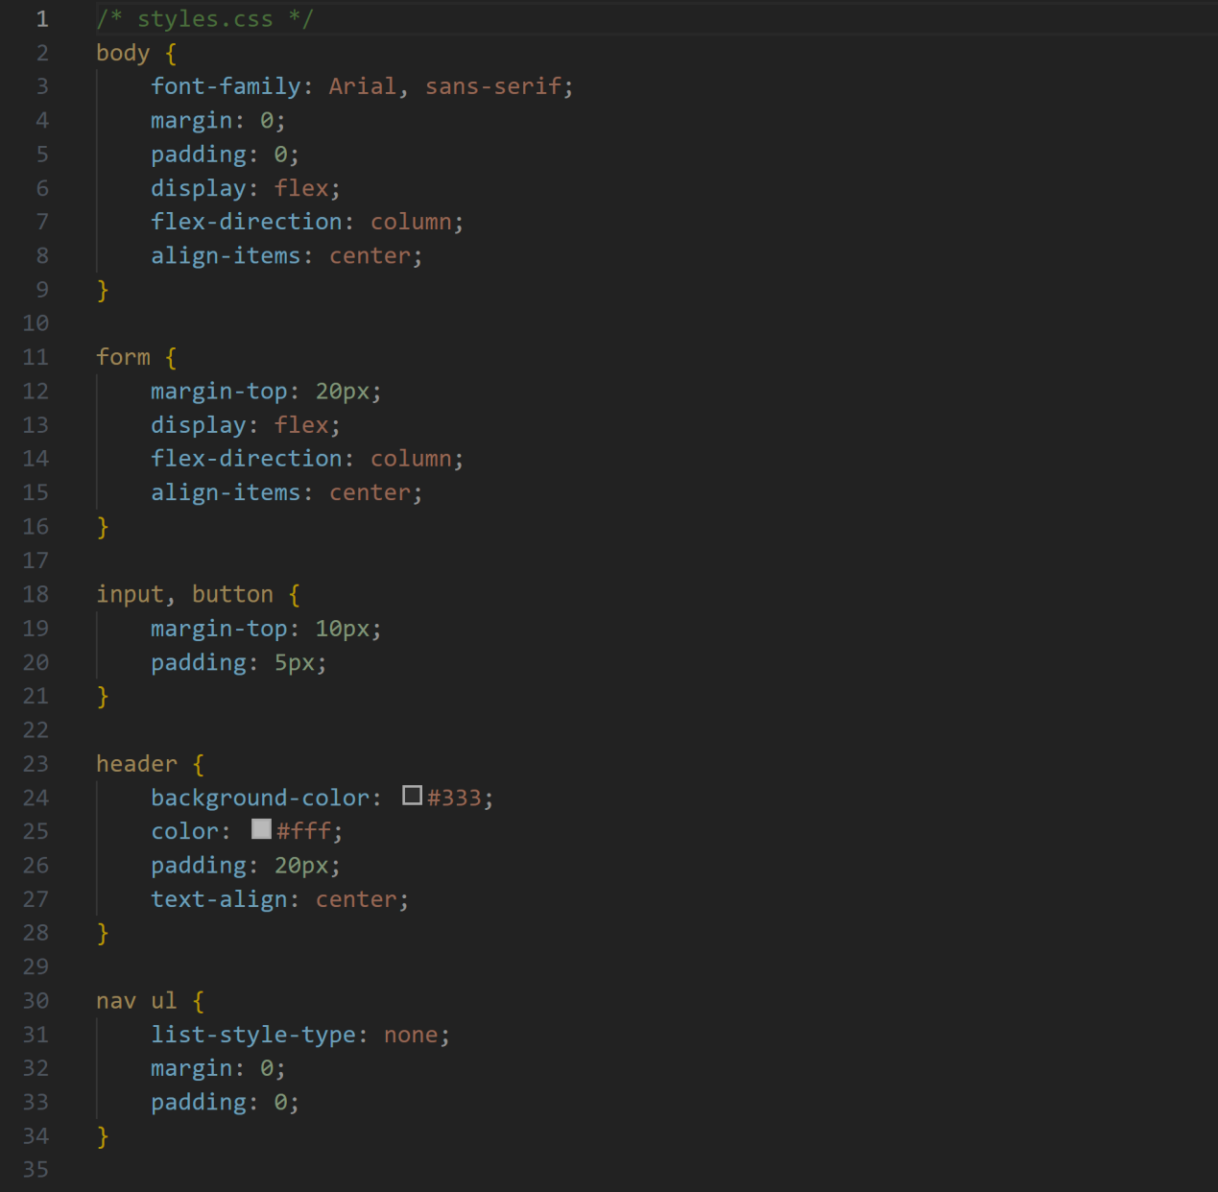

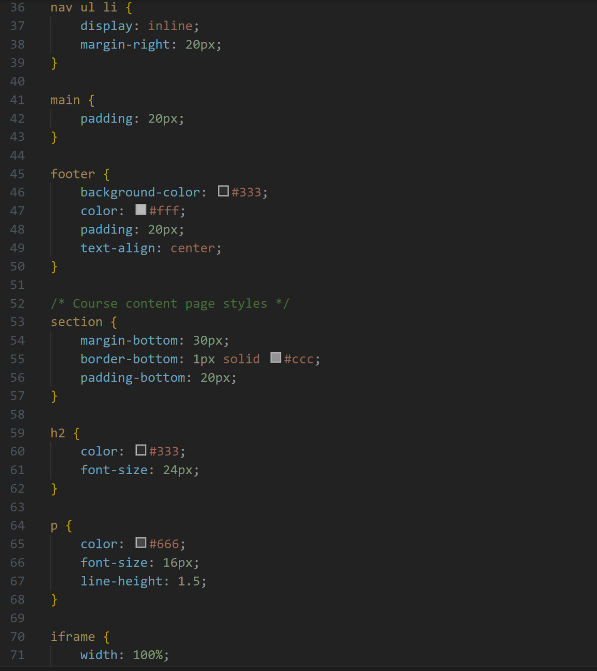

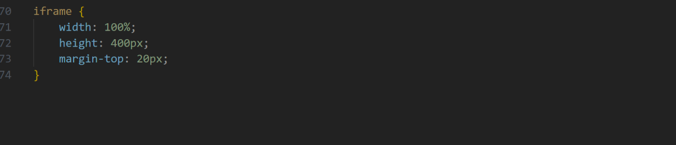

server.js

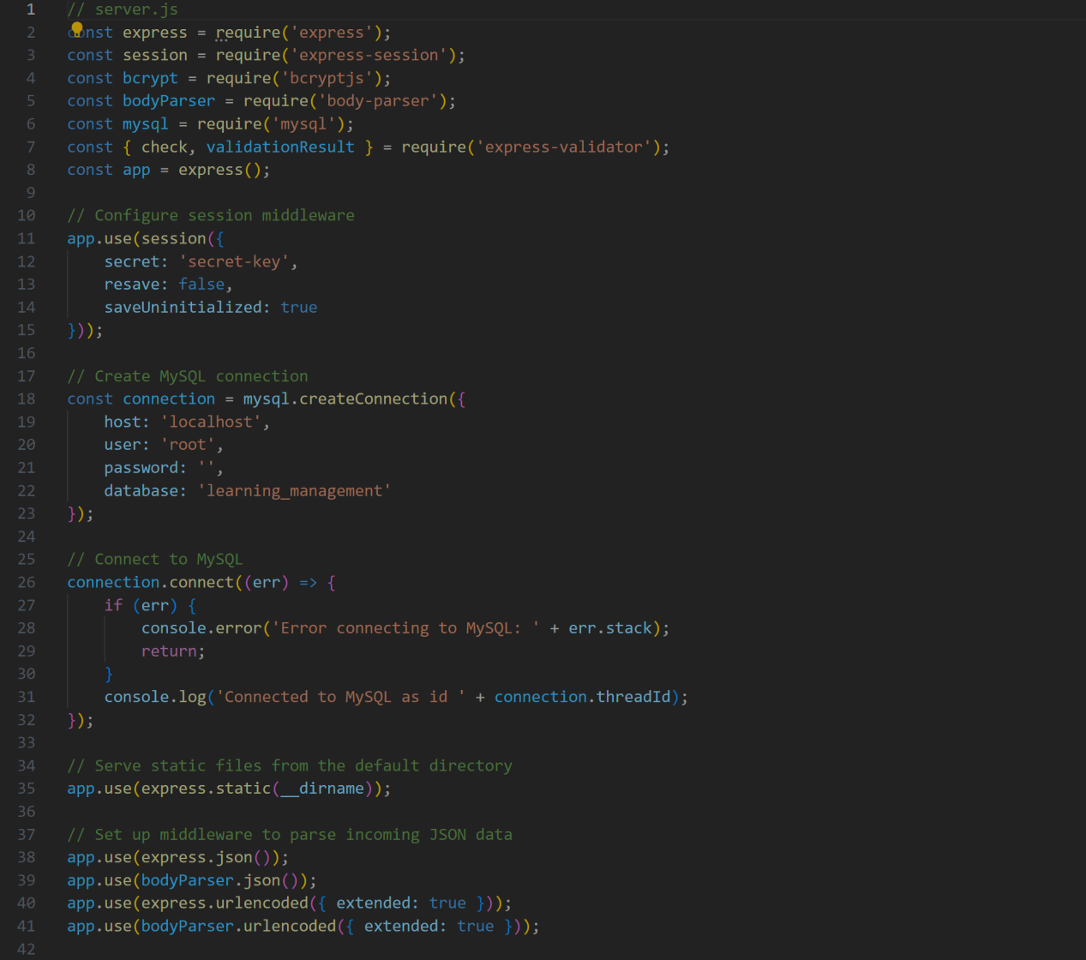
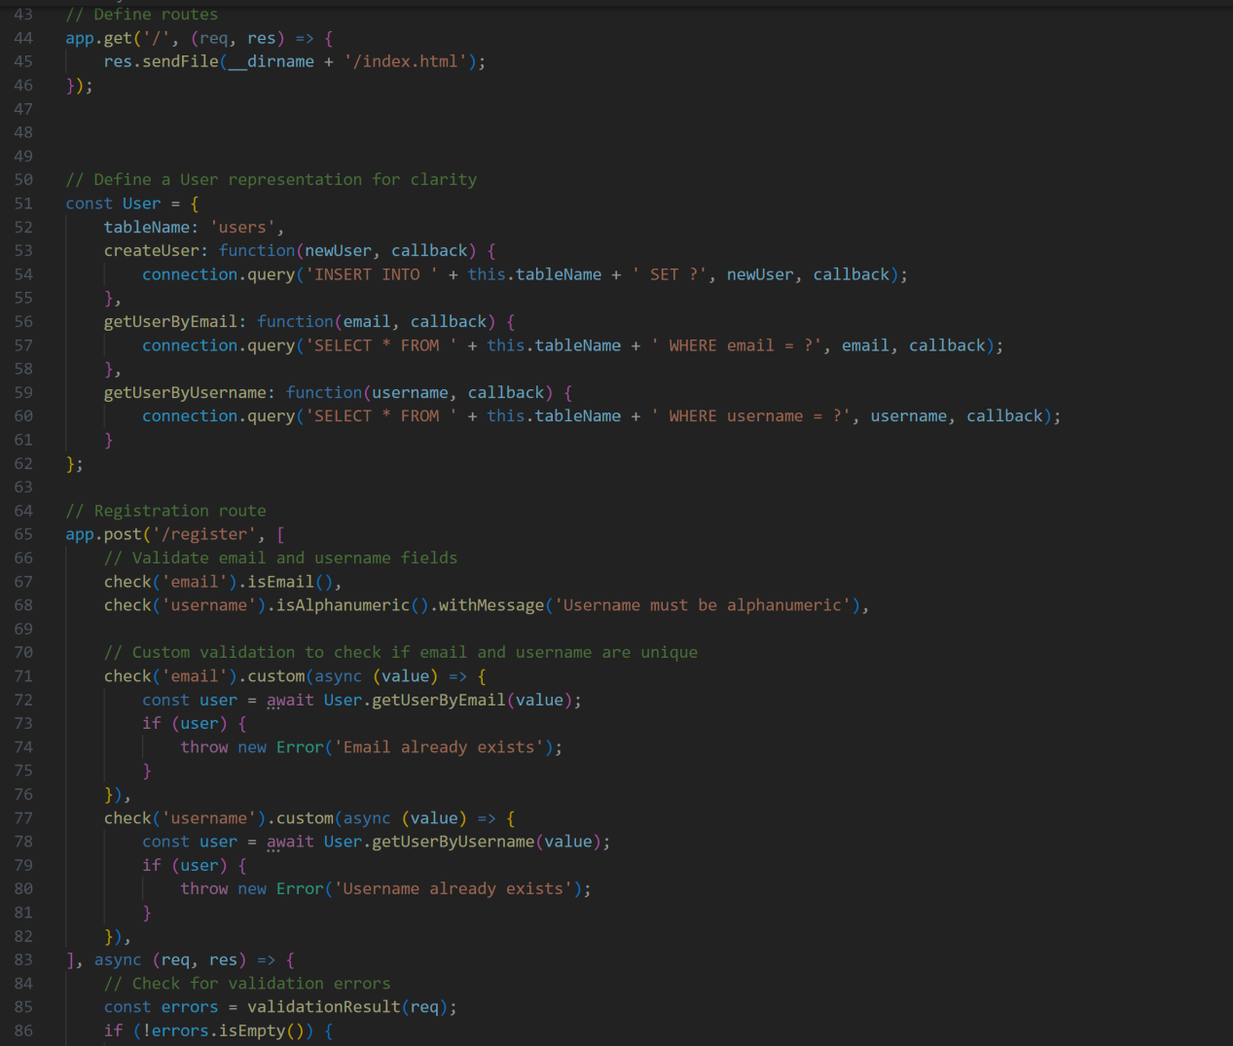
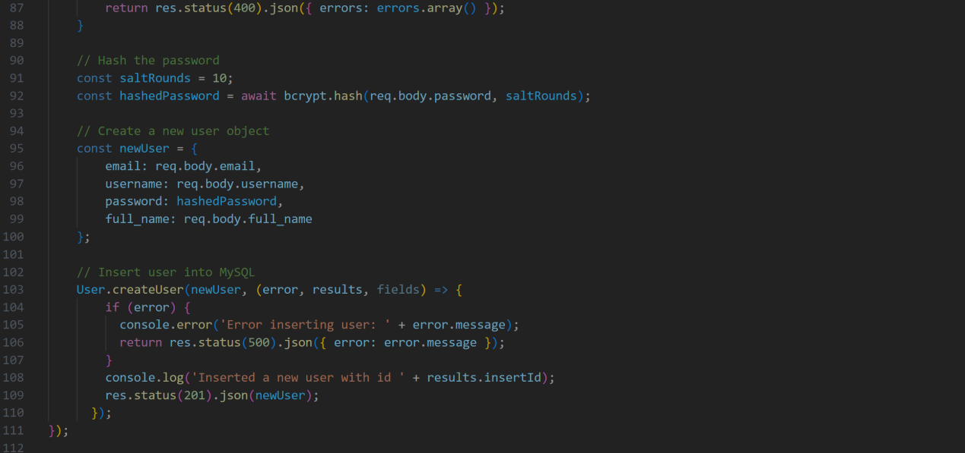
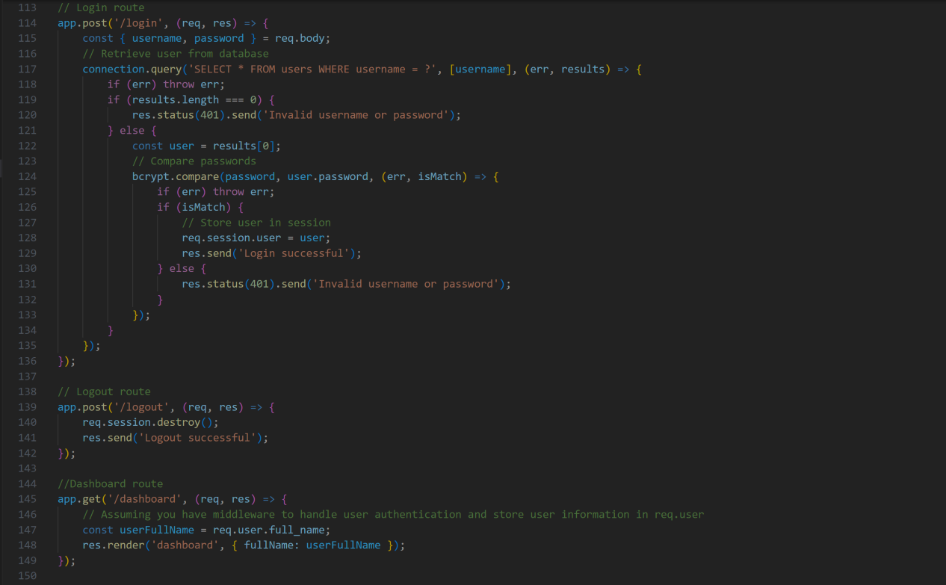

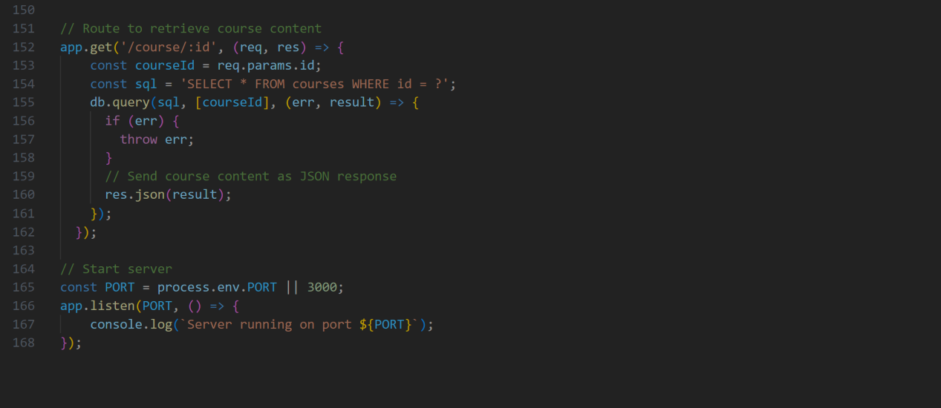

Running the application
To run the application open your terminal and start the NodeJS by typing:
node server.js

